LOCATION RECONNAISSENCE

SCOUTING OUT
The filming site is very open and large enough to film a decent amount of footage that all look different and can vary in styles. It is very floral and has plenty of greenery to add to the scene.
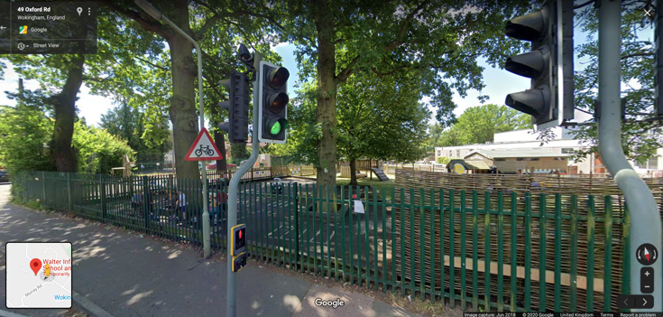
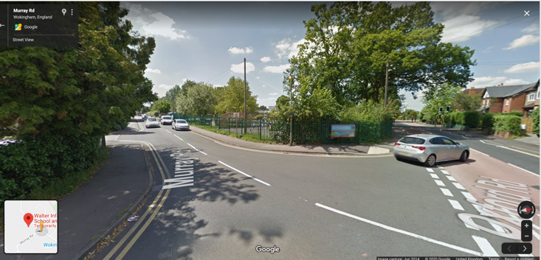
PHOTOGRAPHIC EVIDENCE

DIMENSIONS
The location consists of two large roads that are in a residential area with the two schools (one an infant and the other a primary school) are in the center. It is a large area that we can film the outside of with ease.
LIGHTING
The location is all outside so it lighted very well with the natural sunlight and the only problem we could encounter whilst filming is the sun being too bright and intense that it blacks out the filming site.
SAFETY
As the location is on two main roads it could be quite dangerous to film because of the traffic. It is busiest for the school runs in the weekdays but due to the current situation, the roads are basically abandoned. The only other danger would be sun burn due to the heat wave currently occurring but that can be resolved very easily with sun cream.
RESTRICTIONS & LEGAL MATTERS
As I will be filming on public land it is ok to film the outside of the two schools. The only issues would be with the few school children when they come outside. To avoid any issues, I will avoid filming any of the staff or students with in the schools gates as it could cause conflict with parents and teachers for the safety of the children.

